Final Exam practical

In this Final Practical you will be reviewing the networking that you have learned in your program. You will be using Packet Tracer for the lab.

Your network will a class B network based on a number assigned by your professor, which you will be using for the duration of the class. In the lab anytime you see an underline you should fill in this number.

**Student network: 10.____.0.0/16**

**Task 1 – Create and configure the network**

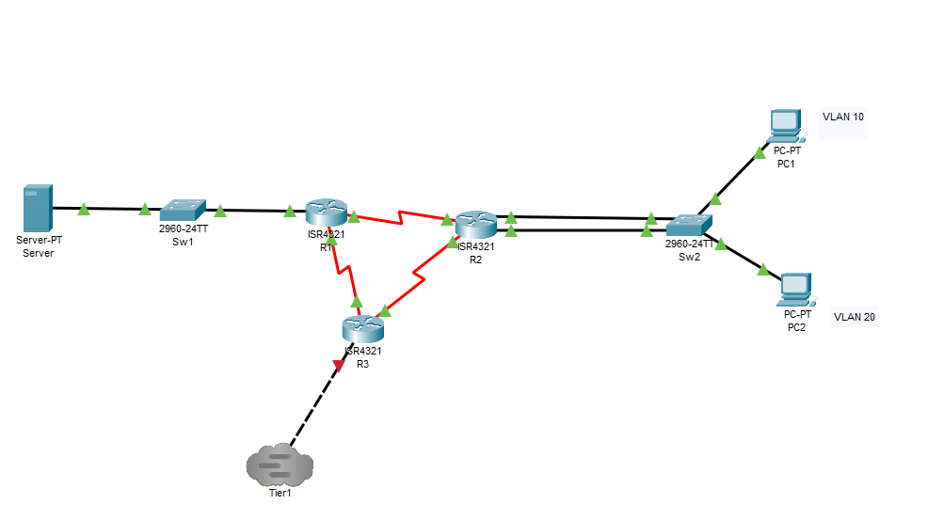

**Program your network as an IPv6 network**

Program each of your routers and switches for the above network.

|  |  |  |  |
| --- | --- | --- | --- |
| **System** | **Port** | **Connect To** | **IP address** |
| R1 | G0/0/0 | Sw1 | 2001:DB8:___:1::1/64 |
|  | Se0/1/0 | R2 | FD00:0:___:9::1/64 |
|  | Se0/1/1 | R3 | FD00:0:___:11::2/64 |
| R2 | G0/0/0 | Sw2 | 2001:DB8:___:2::1/64 |
|  | G0/0/1 | Sw2 | 2001:DB8:___:3::1/64 |
|  | Se0/1/0 | R3 | FD00:0:___:10::1/64 |
|  | Se0/1/1 | R1 | FD00:0:___:9::2/64 |
| R3 | G0/0/0 | Tier1 | 2001:DB8:11:1::___/64 |
|  | Se0/1/0 | R1 | FD00:0:___:11::1/64 |
|  | Se0/1/1 | R2 | FD00:0:___:10::2/64 |

Program each router as show above. An example is given to program R1.

R1(config)# ipv6 unicast-routing

R1(config)# interface g0/0/0

R1(config-if)# ipv6 enable

R1(config-if)# ipv6 address 2001:DB8:___:1::1/64

R1(config-if)# interface s0/1/0

R1(config-if)# ipv6 enable

R1(config-if)# ipv6 address FD00:0:___:9::1/64

R1(config-if)# interface s0/1/1

R1(config-if)# ipv6 enable

R1(config-if)# ipv6 address FD00:0:___:11::1/64

Program each of the remaining routers. Pull and IPv6 address to each PC by clicking on the Auto Config button in the IPv6 configuration.

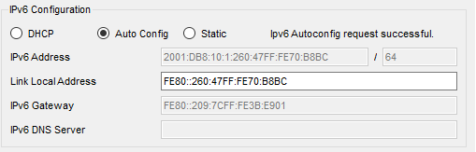

Setting up OSPFv3

Program into each router as follows

R1(config)# ipv6 router ospf 1

R1(config-rtr)# router-id 1.1.1.1

R1(config-rtr)# interface g0/0/0

R1(config-if)# ipv6 ospf 1 area 1

R1(config-if)# interface s0/1/0

R1(config-if)# ipv6 ospf 1 area 0

R1(config-if)# interface s0/1/1

R1(config-if)# ipv6 ospf 1 area 0

R2(config)# ipv6 router ospf 1

R2(config-rtr)# router-id 2.2.2.2

R2(config-rtr)# interface g0/0/0

R2(config-if)# ipv6 ospf 1 area 1

R2(config-rtr)# interface g0/0/1

R2(config-if)# ipv6 ospf 1 area 1

R2(config-rtr)# interface s0/1/0

R2(config-if)# ipv6 ospf 1 area 0

R2(config-if)# interface s0/1/1

R2(config-if)# ipv6 ospf 1 area 0

R3(config)# ipv6 router ospf 1

R3(config-rtr)# router-id 3.3.3.3

R3(config-rtr)# interface g0/0/0

R3(config-if)# ipv6 ospf 1 area 0

R3(config-if)# interface s0/1/0

R3(config-if)# ipv6 ospf 1 area 0

R3(config-if)# interface s0/1/1

R3(config-if)# ipv6 ospf 1 area 0

Verify that your OSPFv3 routing is working by using the command *show ipv6 route* on your R3 router to show the IPv6 routing table. Take a screenshot.

Go to your server and copy your IPv6 address below. You can find it on your IPv6 configuration tab or by typing ipv6config in a command prompt window.

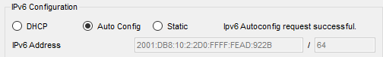

Go to your PC1 and ping the server’s IPv6 address. Below is an example.

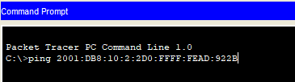

Take a screenshot of your successful IPv6 ping.

**Deliverables**

* Screenshot of your working network
* Screenshot of you IPv6 routing table from R3
* Screenshot of your successful IPv6 ping from PC1 to the server

PASTE SCREENSHOTS BELOW

**Task 2 – Connect to Tier1 using IPv6**

Connect your network through to the Tier1 Network and set up the Tier 1 network to run on IPv6 only. Make sure you configure OSPFv3.

|  |  |  |  |
| --- | --- | --- | --- |
| **System** | **Port** | **Connect To** | **IP address** |
| Tier 1 | F0/0 | Tier1Sw1 | 2001:DB8:11:1::1/64 |
|  | F0/1 | Internet | 2001:DB8:11:2::1/64 |

Connect through the cloud to your Tier1 network. Take a screenshot of your working network and the Tier1 network once successfully connected.

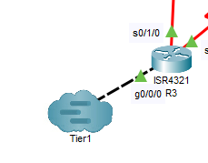

Verify that your IPv6 network is working by pulling a show ipv6 route from your R3 router. Take a screenshot.

Go to your Tier1 server and copy your IPv6 address below. You can find it on your IPv6 configuration tab or by typing ipv6config in a command prompt window.



Go to your PC2 and ping your Tier1 server using the IPv6 address. Below is an example.



Take a screenshot of your successful IPv6 ping.

**Deliverables**

* Screenshot of your working network and Tier1 network
* Screenshot of you IPv6 routing table from R3
* Screenshot of your successful IPv6 ping from PC2 to the Tier1 Internet Server

PASTE SCREENSHOTS BELOW